

كلية العلوم الحاسوبية والمعلوماتية

Faculty of CSI

TO DO LIST

*Students:*

|  |  |
| --- | --- |
| Jawad Qaher Alshamaileh | 202230091 |
| Mustafa Yousef Suleiman | 202310418 |
| Dana Emad Al-Zafari | 202310921 |

*Supervisor:*

Dr. Ahmad Mah'd Khalil Alajarmeh

*Amman - Jordan*

*2024/2025*

Table of Contents

1.1 Problem Statement and project Scope page 1

1.2 Project Plan and Schedule

* 1. Problem Statement

Managing daily tasks without an organized system often leads to missed deadlines, reduced productivity, and stress. There’s a need for a simple tool to help users track, prioritize, and complete tasks efficiently.

* 1. project Scope

The (To-Do List Application) is a C# Windows Forms project designed to allow users to:

* Create and manage a list of tasks: This includes adding new tasks, editing existing ones, and deleting completed tasks.
* Organize tasks: This may involve features like categorizing tasks, setting priorities, and assigning due dates.
* Track progress: This could include marking tasks as completed, viewing a list of completed tasks, and potentially generating reports.
* Set reminders or timers: This allows users to receive notifications or alarms for upcoming deadlines or tasks.
  1. Project Plan and Schedule

Figure 1: Gantt Chart of project

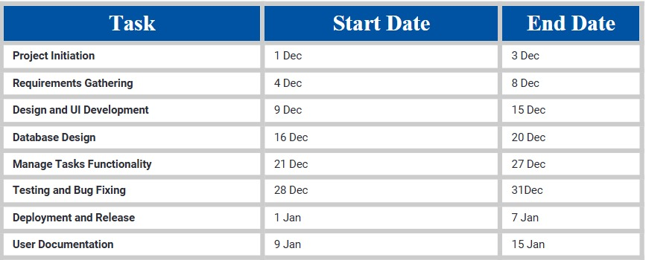

4. System Analysis

4.1 Functional Requirements

1. Task Management:

Add, edit, and delete tasks.

Mark tasks as completed and view completed tasks.

Undo completion of marked tasks.

2. Task Organization:

Set due dates for tasks.

Prioritize tasks (e.g., high, medium, low).

Categorize tasks (e.g., work, personal, errands).

Implement search functionality for tasks.

3. Timers and Reminders:

Set timers for tasks with countdown functionality and alerts.

Set reminders for tasks based on due dates or custom intervals.

4. Reporting:

Generate reports summarizing tasks (pending and completed).

Allow customization of reports (date range, category, priority).

4.2 Use Case Diagram

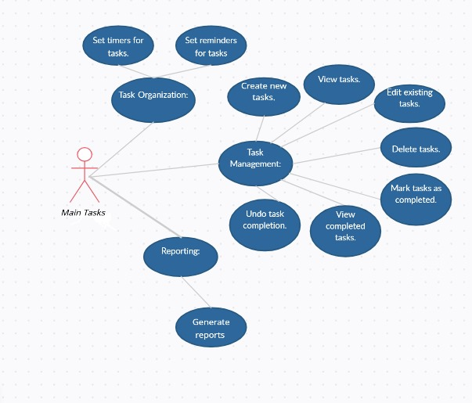

5. System Design

5.1 Class Diagram

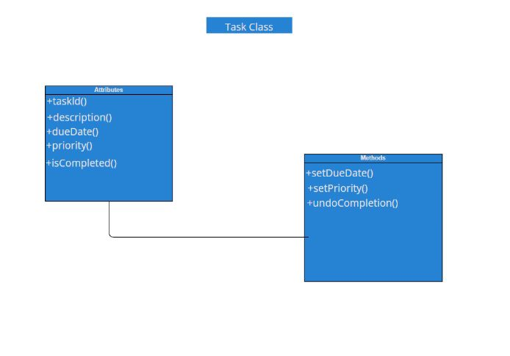

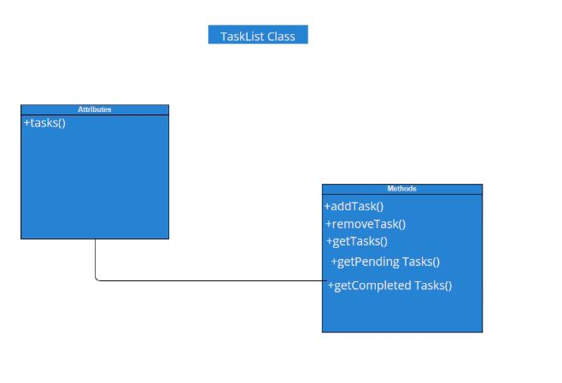

* 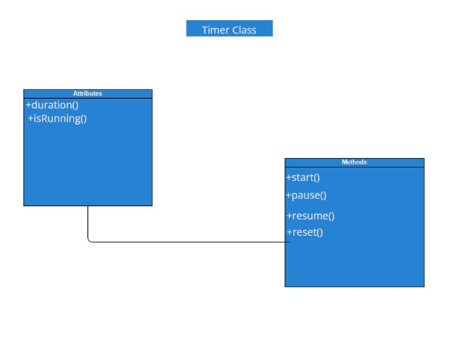

5.2 User Interface

The interface design of the To-Do List app focuses on simplicity and efficiency, allowing users to complete their tasks easily and without complexity.

Interface highlights:

• Task List View:

* Clear display of task details (description, due date, priority, completion status).
* Easy to add, edit, and delete tasks.
* Ability to filter and sort tasks (by due date, priority, etc.).

• Timer/Reminder Section:

* Intuitive controls for setting timers and reminders.
* Clear visual indicators for active timers and upcoming reminders.

• Report Generation:

* Simple and effective way to generate reports.
* Options to customize report content and format.